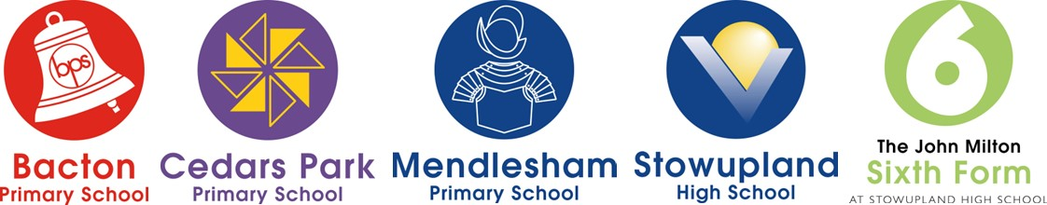

**In-Year Application Form 2024/2025**

|  |
| --- |
| We strongly recommend that you read the Guidance for In-Year Admissions 2024/2025 before completing this form as well as the information for the 2024/2025 school year available online at [**www.suffolk.gov.uk/admissions**](http://www.suffolk.gov.uk/admissions)or contact the Admissions Team on 0345 600 0981 or by email: [**admissions@suffolk.gov.uk**](mailto:admissions@suffolk.gov.uk)  Please also look at the School Travel Policy at [**www.suffolkonboard.com/schooltravel**](http://www.suffolkonboard.com/schooltravel) |

## Please print in capital letters

|  |  |  |  |  |  |
| --- | --- | --- | --- | --- | --- |
| **Child’s details** | | | | | |
| Child's legal last name: | | First name: | | | Middle name(s): |
| Child’s date of birth (DD/MM/YYYY): | Male:    Female: | Current Year Group: | Year Group applying for: | Does your child have an Education, Health and Care (EHC) plan? (see **Note 1**)  Yes: No: | |
| Is the child in care (looked after child)?  (see **Note 2**):  Yes: No: | | Was your child previously in care? (see **Note 3**):  Yes: * No: | | *If you have ticked Yes, please tick this box to confirm if you have attached evidence: | |
| Was your child adopted from state care outside of England? (see **Note 4**):  Yes: No:  Please provide name and contact details of any Local Authority who has been involved: | | | | | |
| Child’s current address: (see **Note 5**) | | | | | Postcode: |
| Name and address of current/previously attended school or education provision: | | | | | |

|  |  |  |  |
| --- | --- | --- | --- |
| **Applicant’s details – parent/carer** (see **Note 6**) | | | |
| Parent/Carer: Mr / Mrs / Miss / Ms / Other  Last name: | Initials: | | Relationship to child: |
| Telephone numbers: | Email address: | | |
| Address if different to the child’s, including the postcode: | | | |
| Are you privately fostering this child? (see **Note 7**) | Yes: | No: |  |
| Are you a UK Service/returning Crown Servant Family? Yes: No: | | | |

|  |  |
| --- | --- |
| **Other details** | |
| **If you are moving house, please fill in these boxes** (see **Note 5**) | |
| Child’s future address, including postcode: | Date of move: |

**Your child cannot be guaranteed a place at any school**

|  |  |
| --- | --- |
| **School preference** (please see **Note 8** on school travel) | |
| Please write your school preference in this box: | When would you like your child to start at your preferred school: |
| Reasons (you do not have to fill in this section if you do not want to, see **Note 10**): | |
| Do any of your other children attend this school? (see **Note 9**)  Child’s name: ............................................................................................. Date of birth: ........................................  Child’s name: ............................................................................................. Date of birth: ........................................  Child’s name: ............................................................................................. Date of birth: ........................................ | |

|  |  |
| --- | --- |
| **Data Protection** | |
| The School / Academy Trust will use the information you have provided in your application for a school place in accordance with the General Data Protection Regulations 2018. Our Privacy Notice is available on our website: [Privacy Notices](https://www.johnmiltonacademytrust.co.uk/page/?title=Privacy+Notices&pid=23) or you can request a paper copy by contacting the Trust on: 01449 742422.  Suffolk County Council’s Privacy Notice is available at [**www.suffolk.gov.uk/CYPprivacynotice**](http://www.suffolk.gov.uk/CYPprivacynotice). This privacy notice tells you what information our schools and Suffolk County Council’s Children's Services collects and uses, and your rights regarding your information. You can request a paper copy by contacting SCC on 0345 600 0981. | |
| **Parental declaration (MUST be completed)** | |
| I confirm that I have read the Guidance for In-Year Admissions 2024/2025, the admissions policy for the school applied for, the relevant information for the 2024/2025 school year online at [**www.suffolk.gov.uk/admissions**](http://www.suffolk.gov.uk/admissions)or contacted the School or Admissions Team. I have read the School Travel Policy and understand how eligibility for Suffolk County Council funded school travel will be decided. I also confirm that the information I have given on this form is true and that I am a parent of this child as defined under section 576 of the Education Act 1996, please see **Note 6**. | |
| **Parent / Carer’s signature:** | **Date:** |

|  |  |  |  |
| --- | --- | --- | --- |
| **Where to send this form (we strongly suggest you get proof of posting)** | | | **School use only** |
| **Bacton Primary** | Tailor’s Green, Bacton, IP14 4LL | [admin@bactonschool.org.uk](mailto:admin@bactonschool.org.uk) |
| **Cedars Park Primary** | Pintail Road, Stowmarket, IP14 5FP | [admin@cedarspark.suffolk.sch.uk](mailto:admin@cedarspark.suffolk.sch.uk) | Date received application: |
| **Mendlesham Primary** | Old Station Road, Mendlesham, IP14 5RT | [admin@mendleshamschool.org.uk](mailto:admin@mendleshamschool.org.uk) |
| **Stowupland High** | Church Road, Stowupland, IP14 4BQ | [enquiries@stowuplandhighschool.co.uk](mailto:enquiries@stowuplandhighschool.co.uk) |  |